Left Navigation _ Multi Firm-20261027_145342-Meeting Recording
October 27, 2026, 6:53PM
42m 8s

Azizi, Ali started transcription

Sharma, Radhika 0:03
with my profile as it is.
When I click on Onboarding, nothing happens, right? Except that it expands and collapses the menu.

Azizi, Ali 0:15
Mhm.
Sharma, Radhika 0:16
You can see I have form-based and I have paper uploaded.
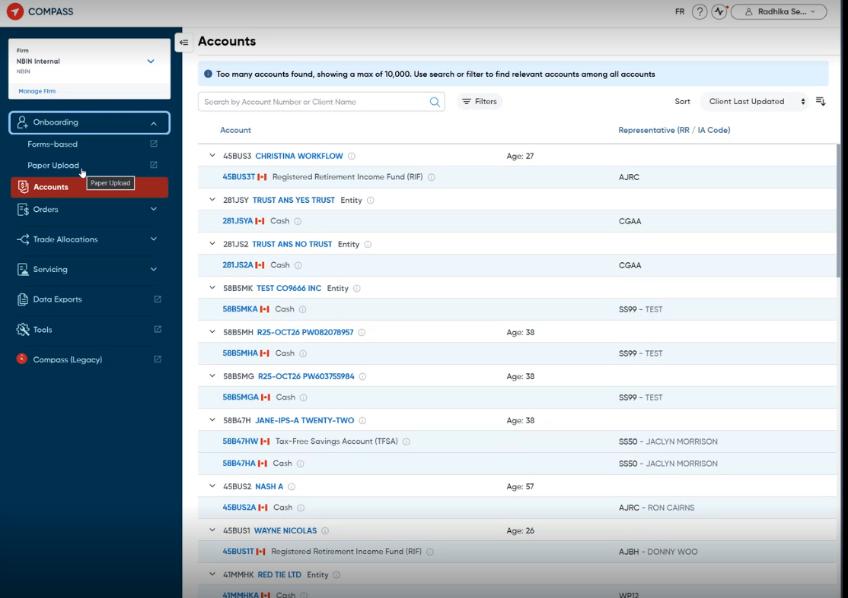
Sharma, Radhika 0:20
To me, this is an acceptable behavior. That's fine. I'm going to go in and I'm going to change my profile.
And I'm going to remove...
Paper upload.
And I'm gonna keep form applications.

Azizi, Ali 0:48
Mhm.
Sharma, Radhika 0:48
No updates.
Now, I don't have a drop-down anymore.
Azizi, Ali 1:06
Mm.
Sharma, Radhika 1:07
When I click this...
it's going to take me straight to form-based Onboarding. So that's problem one.
Azizi, Ali 1:12
No.
Sharma, Radhika 1:16
Is.
Azizi, Ali 1:16
Okay.
Sharma, Radhika 1:18
The client doesn't actually know the feature that they're clicking on.
Now, those that only know that they have form-based onboarding, for them, they might think, okay, form-based onboarding equals onboarding. That's fine. That's my only option. That makes sense. Now, where operationally that has a little bit of an issue is say we have an outage.
or there's an incident related to form-based applications. When our digital support team sends out an alert to say there's an outage or there's an incident, they don't say there's a problem with onboarding. They're going to say there's a problem with form-based onboarding.
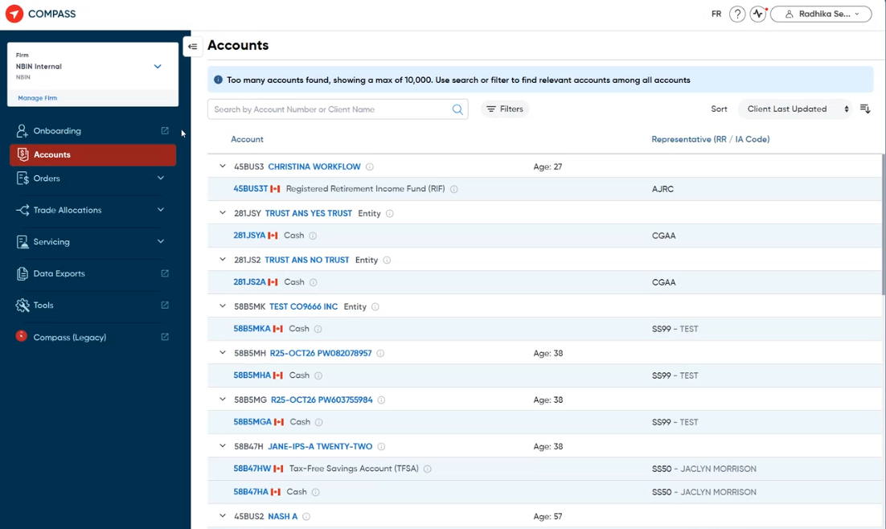
Sharma, Radhika 2:00
So I think from a perception and perspective, it's important that the client can associate any kinds of those kinds of messages or even product communication and associate it to the features that they're using.
So, that's the first issue.
Azizi, Ali 2:15
Yeah, actually, this notification is the consequence of the bad action. But again, the problem, as you showed, it shouldn't just redirect you to the form upload. It should again show that.
Sharma, Radhika 2:16
Then the.
Azizi, Ali 2:37
you know, expand the menu, only show the form upload, and then if the user wants to click on that, then navigate through there.
Sharma, Radhika 2:37
The.
Yeah, and I'll show you like the orders actually works properly. It's not working right now, but I'll show you what I mean in a second. So right now the issue that we have, that's a lie that needs to be addressed is I'm going to go and update my profile again.
Azizi, Ali 2:52
Yeah.
Sharma, Radhika 3:05
And what we know right now is there's three different features that are nested on your Onboarding. So one is the form applications.
Azizi, Ali 3:11
Mm-hmm.
Sharma, Radhika 3:13
Paper upload, so I'll turn that back on.
Azizi, Ali 3:16
Mhm.
Sharma, Radhika 3:17
And then CRS fatca.
Azizi, Ali 3:19
Yes.
Sharma, Radhika 3:19
That's the new one that was added. So I'll add both of it. This is the view. This is the manage.
Azizi, Ali 3:25
Mhm.
Sharma, Radhika 3:26
And while I'm doing that, I'm just going to make another change here quickly.
That's so I can show you the orders case.
So now I'll go back and refresh.
So now we see the menu again. Okay. Now when I click on this now that I've enabled CRS fatca.
Azizi, Ali 3:51
Yes.
Sharma, Radhika 3:56
It opens Sierra's fatca.
Azizi, Ali 3:58
As a default.
Sharma, Radhika 3:59
The drop and the drop-down expands.
And Sierra said because red meaning that is where I am right now.
Azizi, Ali 4:08
Mm-hmm.
Sharma, Radhika 4:08
There is a little bit of history to this though, Ali. So the history to this one is that we have, Evert was working on a new onboarding solution, account opening solution. I don't know if you heard about NIST or questionnaire based onboarding.
Azizi, Ali 4:23
Other.
Yeah, I have a...
Sharma, Radhika 4:26
We stepped away from that relationship and that product, so it's de-implemented.
Azizi, Ali 4:29
OK.
Sharma, Radhika 4:32
That product was supposed to be our primary onboarding solution for our clients. When we launched Compass, we had that, and the idea was when you clicked on Onboarding.
Azizi, Ali 4:38
Mhm.
Sharma, Radhika 4:45
Questionnaire-based Onboarding would open.
Azizi, Ali 4:48
Hom.
Sharma, Radhika 4:48
That made sense because that is your primary Onboarding solution.
But now that we don't have that, we can consider form-based our, you know, our default. But certainly, certainly it shouldn't land on CRS FATCA.

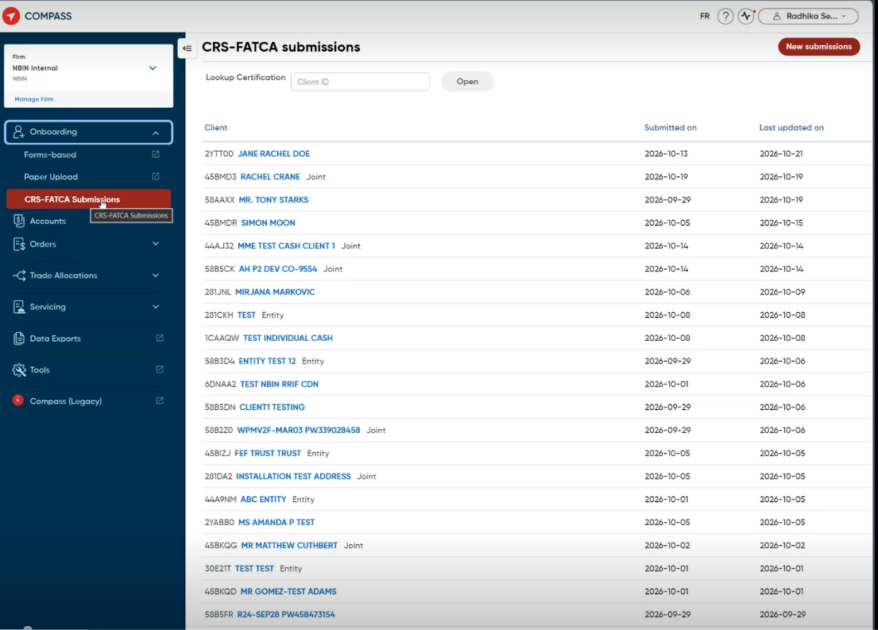
Sharma, Radhika 5:06
Because the same behavior that we saw for onboarding, because CRS FATCA is not an account opening solution, right? It is a, after I've opened the accounts, I need to submit a declaration and I have to use that tool. So now if I were to remove everything else, form and paper again,
This is rare, like this is not really going to happen, this case where somebody only has CRS FATCA. But now, you know, it doesn't open in a new window because CRS FATCA is native to Compass.

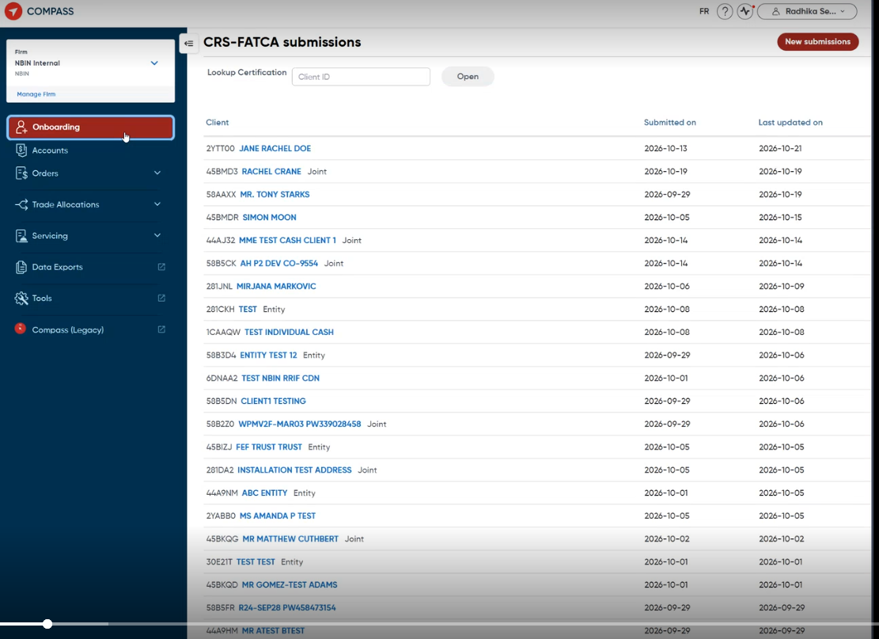
Azizi, Ali 5:40
Oh, and it doesn't show, okay, it doesn't show underlying menu, okay.
Sharma, Radhika 5:41
So.
Exactly. So there is something here where when something is either native or integrated fully with Compass, the top level menu is treating it as, you know, your primary destination when you click on that.
Azizi, Ali 5:48
Nothing.
Okay.
Sharma, Radhika 6:03
Now, see, for orders, that's what's expected, like, for orders, what's happening makes sense to me. So right now, we haven't launched orders at all.
Azizi, Ali 6:14
Mhm.
Sharma, Radhika 6:14
Except for GIC, which is part of trading.
So right now, when a user clicks on orders, nothing happens when I click on this.
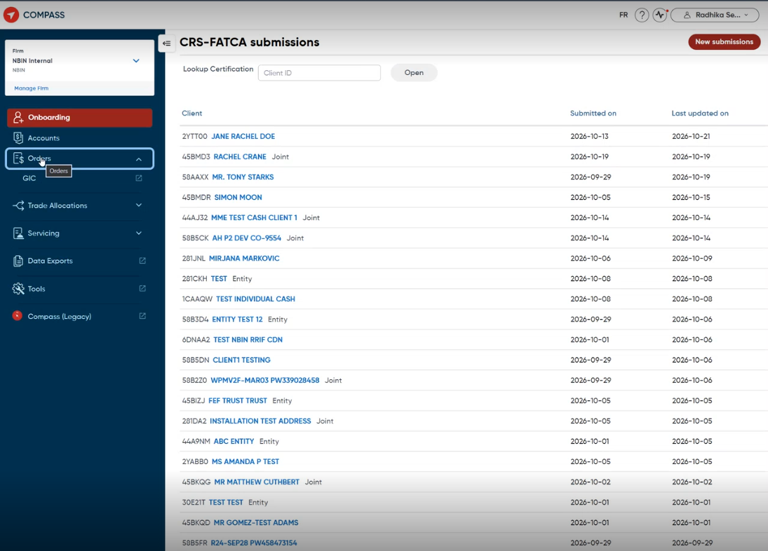
Sharma, Radhika 6:26
I can open GIC.
And there's one menu option, right? There's just one. So why can't that same behavior exist for Onboarding?
Azizi, Ali 6:33
Yeah.
Sharma, Radhika 6:37
The thing with orders is eventually when you click on orders, it actually is going to do something because we have a dedicated module called the orders. It's called orders, which is the order dashboard.
So that will be permanent and it's well thought out because that's exactly what we want. So when I turn on orders here, just turn this on to.
Azizi, Ali 7:00
Mhm.
Sharma, Radhika 7:08
Now, when I click on orders, refresh that.
Now when I click on orders, it presents the order dashboard. That's okay, because this is its own module. Whereas Onboarding is not its own module.

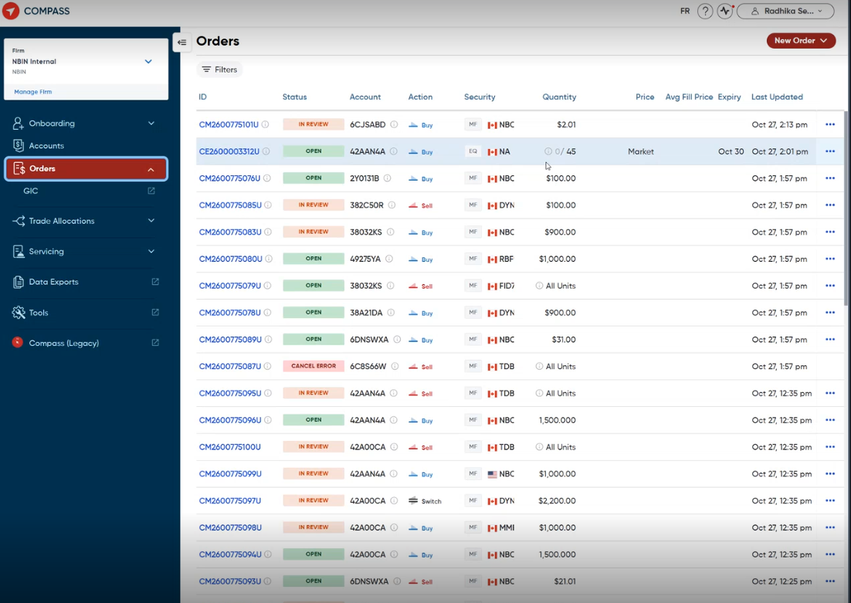

Sharma, Radhika 7:28
So.
This, this was the, this was the issue.
Azizi, Ali 7:30
The problem is only for the orders or other menus have the same issue.
Sharma, Radhika 7:37
Trade allocations is okay also, but I think maybe we need to go back and look at the Figma design. Is there anything else that's going to be under trade allocations? Because we do have, right now I don't see a problem with this if it stands alone on its own, like orders does.
Azizi, Ali 7:39
Okay.
Mhm.
Sharma, Radhika 7:53
But I'm Servicing, I'm worried about.
So right now, Servicing and approvals are integrated modules from the start train.
Azizi, Ali 8:05
Mmh.
Sharma, Radhika 8:06
And file uploads is a new feature that we're going to add. We don't have it here, so I can't show it to you. But file upload is going to be integrated right into here. IIS is building that, and it'll be added here.
I don't know what's gonna happen.
If we introduce that and somebody doesn't have access to Servicing, like what happens? Is it going to be the same behavior as orders? Is it going to be the same behavior as Onboarding where the label will be Servicing, but you're going to go to file upload?
Azizi, Ali 8:36
Mm.
Okay, do you already got all you looking for?
permanent rule and policy for navigating through the menus, left navigation menus, or you want a custom behavior per each menu. What type of...
Behavior you're looking for.
Sharma, Radhika 9:09
I think standardizing the behavior. But even in the standard, I think you can have two options, depending on the grouping, the type of grouping that you have. Like for orders, I think the two options are if you have a module.
Azizi, Ali 9:12
Stan Norris, OK.
Sharma, Radhika 9:29
That is this top menu.
Azizi, Ali 9:32
Mhm.
Sharma, Radhika 9:33
It's okay for it to open.
Because orders is what I'm looking at here. I'm looking at the orders dashboard.
But if I'm clicking on here and...
Azizi, Ali 9:43
And Onboarding doesn't have any native function.
Uh, Sso, okay.
Sharma, Radhika 9:50
Exactly. But see something weird just happened. Remember before when I clicked on this, it didn't show Sierra's fatca. Now it's showing it.

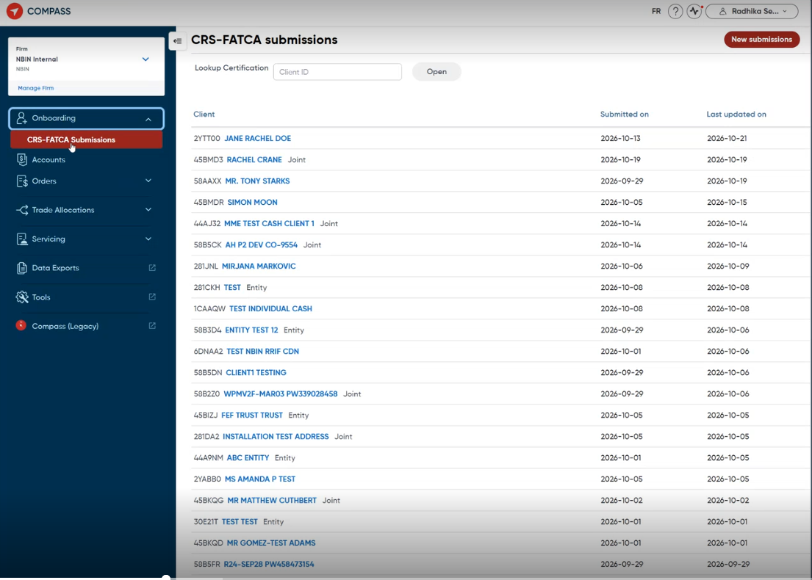
Azizi, Ali 9:58
Mhm.
Sharma, Radhika 9:59
I'm going to refresh and see what happens.
Normally this doesn't show up. Like I think if I log out and log back in, it's not going to show up.
Azizi, Ali 10:14
Okay.
Sharma, Radhika 10:15
But you get the idea, right? Like there's an inconsistency in the behavior. I have ideas of how I think it should work, but I think we can talk about it and come to a common standard, right? Because right now when the tech titans are building something, you know, they're building it native on Compass.
Azizi, Ali 10:18
Yes, yes.
Mhm.
Sharma, Radhika 10:34
They might start putting things in the wrong place.
if we don't give them the right guidance, right?
Azizi, Ali 10:42
Yeah, yeah, makes sense. Makes sense. Okay, I will come up with a...
Sharma, Radhika 10:43
Home.
Azizi, Ali 10:49
standard policy, okay, with some examples. I will provide a draft and then I will review with you and if you think anybody else is required, we can review with them as well. But then if it's fine, then I will ask Esther.
Sharma, Radhika 10:55
Mhm.
Azizi, Ali 11:09
To, you know, to help with what we implement, and also we can have this standard as part of our FOP. I don't know whether it's related to FOP or not, because people usually ask about resources in the FOP.
Are should they concerned about left navigation rules or not? I think yes, they should be.
Sharma, Radhika 11:37
No, because I think that for now, all the navigation rules have been provided by Owen.
they're not provided during the feature onboarding. So they're more in the integration and platform level discussions, which have normally been with Candi and Owen to take to either Sonika's team or Esther's team.
Azizi, Ali 11:57
Uh-huh.
Sharma, Radhika 11:57
Or IIS.
Azizi, Ali 12:00
Okay.
Sharma, Radhika 12:02
But see how the behavior changed again.
Now I don't see CRS again.
Azizi, Ali 12:07
Yeah.
Sharma, Radhika 12:08
So I don't know, it's unpredictable. It's a little strange. But it could just be cache memory from my browser, who knows.

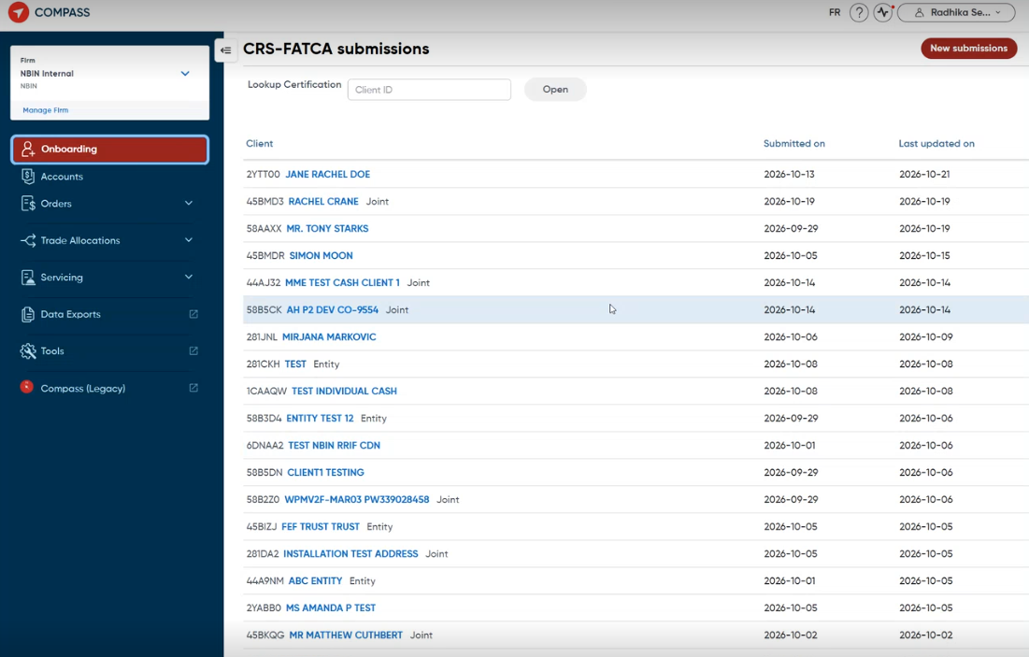
Azizi, Ali 12:12
Yes, yes, that it's.
It's recorded, it's recorded. I will bring those examples in my, yeah, in my proposal. Okay, got it, got it. Yeah, and you need to fix it. It really impacts the user experience for the firms that are using that.
Actually, they they're laughing us, to be honest.
Sharma, Radhika 12:40
Yeah, to them it's, and like, we're trying to make things easier, but we're actually making it harder. And we're about to, like, Kevin and Devendra want to implement system health events. Have you heard about that?
Azizi, Ali 12:54
Yes, Devendra talked to me a few weeks ago about that, yeah.
Sharma, Radhika 13:00
Yeah, so when we implement system health events, we want to call the feature, like every feature will be registered with its own name.
Azizi, Ali 13:08
Mhm.
Sharma, Radhika 13:09
And that name needs to match what's on the left navigation for it to make sense to people.
Azizi, Ali 13:14
Mm-hmm.
Sharma, Radhika 13:15
So we can't accommodate that notification based on all the different names that somebody might see because of the navigation and how it's behaving today.
So I think it's worth noting that, you know, when he wants to go live with this in January, well, I think we need to address, you know, at least onboarding before that so that, you know, we have...
There's no miscommunication to clients.
Azizi, Ali 13:46
Yes, yes, that makes sense. Yeah, yeah, absolutely. Okay, okay, I will come up with a proposal with maybe tomorrow or the day after tomorrow, and we can review that, okay? And then, yeah, talk to the team.
Sharma, Radhika 14:03
Sorry, one more thing, this might come up again.
Azizi, Ali 14:04
Yeah.
Sharma, Radhika 14:08
when we are talking about the secured zone apps. So tomorrow there's a demo. I don't know if you've been invited to that for the secured zone apps.
Azizi, Ali 14:11
Okay.
4 to 5 Pm I think.
Sharma, Radhika 14:21
Yeah, so there we should see the.
Azizi, Ali 14:23
Yeah, yes.
Sharma, Radhika 14:27
the different new categories, because there's going to be new options in the left navigation now. So it could be a good opportunity for us to vet the behavior of those also, just to see if it looks okay.
Azizi, Ali 14:33
Mhm.
OK, this menu is this this demo is going to be take place by IIS team or internal.
Sharma, Radhika 14:47
Esther, Esther's team.
Azizi, Ali 14:48
Oh, it's Thursday, OK.
Okay, okay, I will try to provide something by tomorrow. I always try to share it with you to get prepared. But yeah, I could understand what's behind your idea. It's the standardization and yeah, help the user to understand.
with what's in the feature permissions against the user and what's again what's going to be in the left nav and something doesn't get invisible or on the fly.
Sharma, Radhika 15:22
Yeah.
Yeah, yeah.
Azizi, Ali 15:28
Okay, that's great. Okay, regarding multi-firm.
To be honest, yesterday I got a bit, I don't know, confused or misunderstanding about having two IDs when it comes to the delegation. So it means that still...
The user needs to have, if there is a delegated permission, then they need 2 credentials. Otherwise, it's going to be solved with one user for aggregation, and through that aggregation, they can see the whole.
Access or codes for the old child firms and so forth.
That's good, but still, when it come, you know, I hate when we when we don't when we can't do it to one single ID. To be honest, it's again, user says why I should have two IDs.
Okay, Ai.
Sharma, Radhika 16:43
Yeah, so I don't disagree with you. I don't. The reason that was explained to me, and sub-advisor, which is the delegation I think that you're talking about, is not something I'm totally familiar with. And it's great that we have Ray now because he can help us confirm if the thought process that Owen and JP were running with is correct.
It sounded like he didn't have questions on it yesterday, but I think he's going to process that. So the reason, and I made it more simple diagram for myself that I'll show you.
I'll share this page. This is my cleanup page on like the data cleanup, access cleanup that we have to do. So just for my team's sake, I created these diagrams. So this is our current state. And then down here I have what would our future state be with.
with the different IDs. Now, I might actually, based on your question, and even just for my team's benefit, I'm going to update this to take it to the level that explains the difference and why as a sub-advisor and parent-child relationship or the delegation, do you need two Compass IDs?
because it's missing from here. The core reason is that when you are operating under your parent firm,
You're allowed to do a lot more, you know, perform a lot more actions and service your client in many ways. You're allowed to open their accounts. You are allowed to fund their accounts. You are allowed to send them payments from their accounts. There's a lot more that you can do when you operate under the parent.
Azizi, Ali 18:27
Yes.
Sharma, Radhika 18:29
But as a sub-advisor, and this is the part that I'm not 100% clear on, is as a sub-advisor from what Penny and Owen have shared, you should only be limited to perform trading related functions.
Azizi, Ali 18:37
And...
Sharma, Radhika 18:45
So the idea is that you need to kind of create two separate types of user personas. You need to have a type of persona who can service a client in every way. And then you need a persona that can service clients in only specific ways.
And because the feature access is tied to your ID.
If I give you feature access here to do service a client in every way.
and we just attach your sub-advisor R codes to this profile, you can now perform those actions for everybody, not just your home firm clients, but also those that you sub-advise to. It might not even be a real case. I'm doubtful that you're going to have people who belong here and here.
I think you might just have people that belong here alone. But because I guess from the architecture or the design, it's not possible to create a division in one ID to separate, okay, these are our codes, you can do everything. These are our codes, you can only do some things.
Azizi, Ali 19:41
Mhm.
Sharma, Radhika 19:57
But I'll be honest with you, that already exists in Compass Legacy.
Have you seen that part of Compass Legacy?
Azizi, Ali 20:07
Not with this visibility, but yeah, I would be happy to see that.
Faq.
Sharma, Radhika 20:17
Control your feature access for two different R ranges.
Azizi, Ali 20:19
I think...
Yes, that it.
Let's say this is today restriction, but it's not a law. You know, I am saying that it can it can be changed because there is a there is, for example, let's say there is someone.
In the child of the Harvard Front, now there are three, there are three firms, and someone from the parent wants to see the oracles, all of the three firms, OK?
That's fine. Now, someone from the, let's say, from the child firm needs to trade as behalf of another child firm in the harbor firm, which is which is some which is a.
Sharma, Radhika 21:02
Uh-huh.
Azizi, Ali 21:20
Form of the delegation, OK?
So in that case, maybe not only it needs to have access to its own R code, but also needs to access to the firm B R codes as well. Then it changed the equation.
Sharma, Radhika 21:39
Alright.
Azizi, Ali 21:45
Oh.
Sharma, Radhika 21:46
It does, yeah.
Azizi, Ali 21:47
Yes, and actually I have a solution for that, but we need to talk a little bit. Let's see here first about what you're saying.
Sharma, Radhika 21:59
So this person, we lucked out with found one.
This person on Compass Legacy.
has this ID.
Azizi, Ali 22:09
Oh, Arafan, okay.
Sharma, Radhika 22:11
These are his primary RR codes.
Azizi, Ali 22:15
Yes.
Sharma, Radhika 22:15
This means for these clients, he can do anything on Compass Legacy. Pretty much anything he has permission to do, right, based on his access control.
Azizi, Ali 22:23
Mhm.
Sharma, Radhika 22:25
In Compass Legacy, we have something else called a PM sub advisor RR code.
For these three R codes.
Azizi, Ali 22:31
Mhm.
Sharma, Radhika 22:34
Airin is allowed to do other things.
I don't know specifically what they are, but it could be like the trade file, the mutual fund upload, trade advice uploads, those types of functions, maybe systematic plans, I'm not quite sure. So R2 is already built with a framework that you only need one ID,
Azizi, Ali 22:37
Okay.
Sharma, Radhika 22:55
R2 can separate and distinguish between this are our codes to give you full access to features and this one to only give you access to some.
Azizi, Ali 23:05
Yeah, but we don't know these R codes belong to which firm?
Sharma, Radhika 23:11
Well, we can trace it back, but I mean, the system does, right? Because, so in Compass Legacy, or the way that our firms are structured,
Azizi, Ali 23:13
But, yeah, yeah.
Sharma, Radhika 23:22
Um...
Let me just see if I have it here.
I was supposed to send you that document, and now I'm realizing I should have sent it to you earlier.
Azizi, Ali 23:36
No worries, no worries.
Sharma, Radhika 23:37
This is a representation of some of the relationships that we have in our systems.
Azizi, Ali 23:44
Ohh, great.
Sharma, Radhika 23:50
I don't know if it's reflected here properly.
No, I have a...
I have another diagram I'll find, but I'll try to explain it right now. But our firms, they all have a firm ID, right?
Azizi, Ali 24:07
Yes, yes.
Sharma, Radhika 24:08
Now.
There are a few firms where you'll see here, the ICPM, ICPMB, ICPMC.
We call these our.
Generic.
PM Brokered codes.
Azizi, Ali 24:30
What does that mean?
Sharma, Radhika 24:32
So I'll try to use this diagram here. Maybe it will help.
Azizi, Ali 24:32
January.
Sharma, Radhika 24:38
I don't know if it'll actually, I think I can spend some more time and walk you through it. But firm IDs, the concept of a firm ID only exists in...
Come in Firm 360.
Azizi, Ali 24:52
Yes, Infirm 360.
Sharma, Radhika 24:54
Now, how is that ID constructed?
So let me open up Firm 360 and give you that example. I know we only have a few minutes, but I will think this is important for you to know.
Azizi, Ali 25:06
Yeah, thank you. Yeah, yeah, for sure.
Sharma, Radhika 25:09
And I'm proud to say I was involved with Firms 360 in the beginning, but they've made it so much better and they've done so much with it since then.
But if you look at, let's look at this first one, OK?
So, you can see that the firm ID.
Azizi, Ali 25:32
Mhm.
Sharma, Radhika 25:41
Well, this is the firm ID. ICPMB 18 AM.
Ray.
The firm ID is made-up of the broker code.
And a branch code.
Azizi, Ali 25:54
Oh, great. Okay.
Sharma, Radhika 25:57
In some cases, you don't have a branch code.
Azizi, Ali 26:02
Mhm.
Sharma, Radhika 26:07
And it's usually our brokers, our PMs.
A lot of them were in the shared environment.
You'll see that they have a branch code. This is a this is an IP.
Azizi, Ali 26:18
Mhm.
Sharma, Radhika 26:19
The IBs only have a broker code. So your firm ID can either be a broker code or it can be your broker code under score branch code.
Azizi, Ali 26:22
Okay.
Okay, great.
Sharma, Radhika 26:30
So going back to your question about how do you know whose RR codes these are, especially because here right now I'm under core net investment, right? This doesn't tell me which client because ICPMB is a shared broker code. The branch codes is what helps us identify the individual client under the shared environment.
Azizi, Ali 26:45
Mhm.
Mm-hmm.
Sharma, Radhika 26:51
Here is the client code. So branch code, client code, division code, these are all synonyms for that second-half of the firm ID. And in this case, we're looking at Bellwether. So this RR codes are for Bell W.
Azizi, Ali 27:10
Okay, got it.
Sharma, Radhika 27:11
If I look, if I look up one of these in Firms 360.
Slow.
No.
It tells you that it's for IP, this one, Td.
Azizi, Ali 27:50
Bell.
Sharma, Radhika 27:54
So on new Compass, this client belongs under this firm ID, this under score this. So our systems are smart enough, they know that these are our codes belong to a specific firm. And Compass already knows that because it's reading off of Firm 360.
Azizi, Ali 28:12
Mhm.
Sharma, Radhika 28:14
That's how even today we're able to assign and control what are our codes are available under which firm.
Because Compass is reading from 360 data.
Azizi, Ali 28:25
You mean Legacy Compass, not this, not the new compass?
Sharma, Radhika 28:28
No, no, New Compass as well. So New Compass uses firm 360 data.
Azizi, Ali 28:36
Up to API or?
Sharma, Radhika 28:39
I'm not sure. I think it's a daily, it's a daily job that refreshes it. Yeah.
Azizi, Ali 28:42
Ohh, daily sync, OKOK.
Sharma, Radhika 28:46
So conceptually, Compass Legacy is already doing multi-firm, but it's on a much smaller scale because there's still some limitations, right? Your limitations, so for example, Harborfront.
Azizi, Ali 28:47
Okay.
Mhm.
Sharma, Radhika 29:05
Harborfront cannot.
Like Compass Legacy has the concept of multi firms specific to sub advisor.
not multi-firm parent child. That doesn't work in Compass Legacy. Because Harborfront here has, you could see there's no field for me to enter another set of our codes here.
Azizi, Ali 29:18
Yes.
Yeah.
Sharma, Radhika 29:27
So I have to create multiple IDs in Compass Legacy also.
for Harborfront users.
Azizi, Ali 29:34
Got it. Got it. Okay.
Sharma, Radhika 29:36
But the concept is there.
Azizi, Ali 29:40
Okay, in favor of time, let me share my screen because I want to show you something. Maybe it maps some of your things that you already told me.
It's a...
This is just a mockup. It's just, it's not going to be.
Sharma, Radhika 30:05
I'm really impressed by these mock-ups that you do though, I have to say. They're very impressive.
Azizi, Ali 30:09
No worries.
Yeah, just my understanding. I try to, you know, I try to get it more visualized and get it more understandable to see if for myself to understand whether I am on the right track or not, to be honest. But
Sharma, Radhika 30:26
Honestly, like it's so much easier to provide feedback even with a conceptual like workflow because oftentimes feedback is requested reading a page and you just can't picture it. So this is very helpful.
Azizi, Ali 30:37
Exactly.
Yeah, yeah, yeah. Okay, actually, this is the, this is the, this is for the firm security Stewart. It's the number, it's the users. As you see, I have provided all the firms. If, for example, Harbor Front Group, I have provided all the child firms underlying that.
For example, for Cumberland, Wellington, Altus, and so forth. OK, now I am assuming that these data are coming from Firm 360 via API or via daily sync, whatever, but I can I can build this hierarchy, OK?
Sharma, Radhika 31:22
One quick comment, today we are not consuming or any parent information.
Azizi, Ali 31:30
Yeah.
Sharma, Radhika 31:31
Yeah, that's the part that Ray was talking about, but he needs to get Darwin to support.
Azizi, Ali 31:32
Yeah.
Yeah, we could, we can, for the start, we can do it, you know, static with a file or whatever, but then we can build it out and make it through API. But I think it's going to be more better to understand all the relationship, because here...
I provided all the relationships through, you know, through, sorry, here, I think, yeah, groups. These are the groups that are parent-child. You see, for example, I can add a firm, I can see number of the users, it's...
PM, IB, you know, or whatever, okay?
And say, OK, what what Firms are?
are underlying the Harborfront group. So, for example, KJ Harrison, Rodenberg, or whatever. And, but back to the firm, so I have these users, so each user can have a profile, okay?
And in that profile, I can define where it can reach. For example, for Aaron Chan, if I modify, if I right now, I can say, okay, it can, if I click on modify, I can say.
It can see the whole Harbor Front group. OK, or I can say, OK, not the whole, I can select one by one, or I can say, OK, only two of them. OK, let's say it's now.
Only K.J. Harrison and Velkans, that's all, and the underlying R codes, as you see, has been defined here as well when I when I create the relationships.
And.
Sharma, Radhika 33:40
That's the full range or that specific R codes for this user.
Azizi, Ali 33:45
That's the full range for this firm.
Sharma, Radhika 33:49
Okay.
Azizi, Ali 33:51
Okay, so this user is going to get access to the full range of the wealth console, okay, which is defined from the firm relationship and KJ Harrison, but if you think it should be customized, it should not be.
have access to the full range of the firm, please let me know if this is a business requirement.
Sharma, Radhika 34:18
It is, yeah.
Azizi, Ali 34:19
Okay, okay, now I got it. Okay, so it's not like that they can, okay, they should be able to customize this range per each firm. Okay, that's a good feedback. And then about the feature,
I keep it as it is, okay? I can add or I can select more, or you know, I can remove or add whatever, okay? So, for example, for this orange chain, now I have changed the access to K.
K.J. Harrison, and only access to client and account, and I can submit the request, and then if I go to SAA admin, I will see one request over here, which is has been, and then if I want to, I can reject, and if...
I want to say all the things are good. I click on all of them and accept as a security store, sorry, as I say, and saying complete request and that's all.
That's the whole concept, but...
Sharma, Radhika 35:40
I think just one bit of feedback, if we go back to the firm security steward page, we wouldn't want the firm security steward page, or I think it was in the relationships. We don't want the firm security steward defining the relationships.
Azizi, Ali 35:45
Yeah?
Sharma, Radhika 35:56
The relationships should be inherited from Firm 360. Right now, though, as we had discussed, Firm 360 doesn't have the sub-advisor, but it has the parent and child relationships.
Because those are contractual, right? A security steward may or may not be aware of those contracts. Those are established with us. And then we would implement those relationships on Firm 360 and Compass should inherit those relationships.
Azizi, Ali 36:11
Yeah.
Yeah, firm security cannot have any control on that, okay? In this page, they cannot do anything regard. They inherit whatever has been, actually, I name it in Product Activation. Maybe, again, yeah, you see the user here, I can define groups, okay? I can define, add a firm.
Sharma, Radhika 36:30
Hom.
Yeah.
Azizi, Ali 36:48
Firm merge, whatever, or the delegation. Okay, I can provide the delegation as well, and create the delegation profile as well. What it's under, let's say I provide the product activation, okay?
Sharma, Radhika 37:01
Yeah. I think here we have an opportunity if we can get all of this information in Firms 360.
Azizi, Ali 37:08
Yes.
Sharma, Radhika 37:08
And let Firm 360 manage the delegations, manage the grouping.
Azizi, Ali 37:12
Exactly, exactly, exactly. And then, and then here again, if I change to to Guardian Capital here, for example, there is a delegation. OK, now for Nora, I can provide the delegation to say, OK,
This is the delegation that has been created by Production Activation, and I am showing up here as an example. So, if I want to assign this delegation, I need to create that. I need to click on that, and in this delegation, it provides the detail of the delegation.
That is going to delegate the accounts of these three firms to to Nora to manage, OK?
And then I, if I, and you see the other, the other is is disabled, nothing can be, nothing can be added or or changed. Now I can submit, OK?
Sharma, Radhika 38:09
Alright.
I see you.
So you've added the feature level control based on the fact that the access assignment is being done on a delegation.
Azizi, Ali 38:24
Yes, yes, but if there is a requirement to change and help them to modify, it's possible. OK, this the whole the...
Sharma, Radhika 38:36
Now, sorry, the same requirement on the RR codes would exist here too. In fact, more strongly here, right? At any point, a user should be able to select whether they have access to the full range or specific RR codes.
Azizi, Ali 38:40
Oh, oh, okay, okay. Yeah.
Uh-huh.
Good feedback. Okay, yeah, yeah, yeah, that's noted. Okay, yeah, again, again, I can modify, even with that delegation, I can modify, say, okay, no, Nora can see only Fiona and Dandy, not the cancel. So I deselect it and then stop.
Meet, and then it goes to the to the.
Sharma, Radhika 39:12
Can Nora have access to, so you can customize Nora's access to Guardian and her delegation at the same time?
Azizi, Ali 39:20
Yes, yes.
Sharma, Radhika 39:22
And her feature access would be different.
Azizi, Ali 39:27
That's a good question. Yes, actually, right now, the feature access remains the same, actually, because, as you see, as you could see, I don't have this visibility or this access to...
change the features as you see. I can, I can, as you see, I cannot deselect or, oh yeah, I can deselect. I think.
Sharma, Radhika 39:54
Mm.
But only the ones that are within that group, right? Like for her, for her, for her access to Guardian, she might want to be able to do onboarding, which you cannot select or unselect.
Azizi, Ali 39:58
Yes, yes, yes, yes.
Oh, okay.
Sharma, Radhika 40:10
Right? So this is the reason why Owen has separated the identity between your home firm and your delegation or sub advisor.
Azizi, Ali 40:24
OK, but, but it can be changed, you know, it can be changed. It's not, it's not a big deal, you know, it's just a mock-up. I can, I can change it, and I...
Sharma, Radhika 40:34
So just from a requirement perspective, I love where you're going with this. And I even like what Ray had brought up the other day around toggling, right? Like even if you have one identity of a person, you can have, you know, two sections, one for its delegation.
Azizi, Ali 40:35
Yeah.
Yeah.
Yeah.
Sharma, Radhika 40:51
R and feature access and one for its home firm prime like access, as long as the user can toggle between the two.
The the the requirement is met, right?
As in, can I toggle between 2 profiles?
Azizi, Ali 41:09
Yeah.
Yes, yes, they can, they can, they can. So yeah, that's the whole thing. I could see that possible. The whole reason I provided is that because yesterday, some people in the room said, okay, it may take three months to go through design discovery.
And I really got ****** ***, to be honest. You know, I think it's two weeks. For me, if you are on the other side of the table, maybe Esther on the other side of it, it shouldn't take more than two weeks, to be honest.
Sharma, Radhika 41:37
Oh.
Azizi, Ali 41:50
to do the whole design and discover it.
Azizi, Ali stopped transcription

